**Road Accidents in UK**

**Dashboard Summary**

**Report**

**Overview:**

This dashboard is built using **Power BI**, and it provides a summary of road accidents in the UK for the current and prior years. It focuses on key metrics like casualties, accident counts, and factors influencing accidents, such as road type, light conditions, and urban versus rural locations.

The dashboard's visualizations help users easily identify trends, patterns, and high-risk areas for better decision-making and policy planning.

**Objectives:**

* List all of the United Kingdom's traffic accidents from the previous year and the current one.
* Determine patterns in traffic accidents and fatalities over time.
* Point out the main causes of traffic accidents, such as the kind of road, the lighting, and the difference between urban and rural locations.
* Identify geographic accident hotspots.

**Dashboard:**

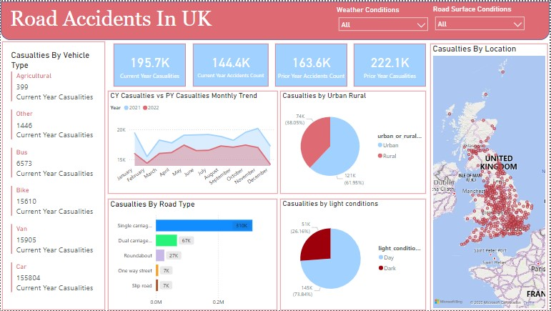

**Key Insights:**

Question 1: How many road accidents and casualties occurred in the current and prior years?

**Current Year Casualties:** 195.7K

**Prior Year Casualties:** 222.1K

**Current Year Accidents:** 144.4K

**Prior Year Accidents:** 163.6K

This shows a decline in both accidents and casualties from the prior year to the current year.

Question 2: What is the monthly trend of casualties in the current year compared to the prior year?

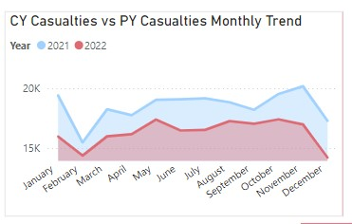

Casualties in both years show a similar trend, with a peak during the summer months (July-August) and a decline towards the end of the year. This indicates seasonal variations, possibly due to increased travel during summer.

Question 3: Which road types are associated with the highest number of casualties?

**Single carriageways:** 31K casualties.

**Dual carriageways:** 6.7K casualties.

**Roundabouts:** 2.7K casualties.

**Motorways:** 7K casualties.

Single carriageways contribute the most to road casualties, suggesting targeted interventions are needed on these road types.

Question 4: Are accidents more common in urban or rural areas?

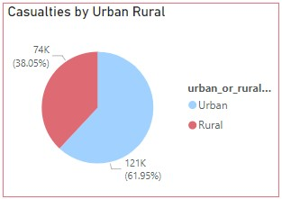

* **Urban Areas:** 121K casualties (61.8%).
* **Rural Areas:** 74K casualties (38.0%).

Urban areas have significantly more casualties, likely due to higher traffic density and pedestrian activity.

Question 5: How do light conditions affect accidents?

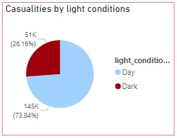

* **Daylight:** 145K casualties (73.8%).
* **Darkness:** 51K casualties (26.1%).

Most accidents occur during daylight, which could be linked to higher traffic volumes during the day.

Question 6: Where are the accident hotspots in the UK?

* Major urban centers like London, Birmingham, and Manchester are highlighted as accident hotspots.
* These regions require focused measures such as improved traffic management and road safety awareness campaigns.

**Conclusion:**

The dashboard provides important insights by effectively summarizing traffic accidents and fatalities:

* A decrease in incidents and fatalities compared to the previous year.
* Urban regions and single carriageways are high-risk environments.
* The majority of accidents happen in the summer and during the day.
* Major cities are concentrated in accident hotspots.

In order to lower accidents and enhance road safety, these findings can help the organizations dedicated to road safety conduct focused measures.